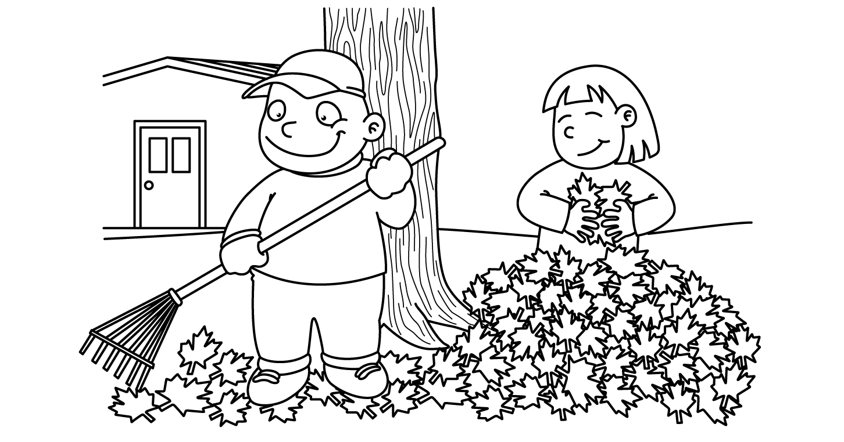

MONTH of OCTOBER
Sunday | Monday | Tuesday | Wednesday | Thursday | Friday | Saturday
1  Please send along 16 snacks. | 2  Henry | 3  Arabella | 4  Westin | 5  Jack | 6  Abigail | 7
8 | 9  Lola | 10  Delaney | 11  Ella | 12  Knox | 13  No School  Teacher In-Service | 14
15  Happy Birthday, Liam! | 16  Liam | 17  Riley  Field Trip | 18  Jessa | 19  Cody | 20  Jackson | 21
22 | 23  Dylan | 24  Henry | 25  Arabella | 26  Westin | 27  No School  Fall Break | 28
29 | 30  Jack | 31  Abigail

